Cafeteria retrofit daylighting study

BASE CASE – NO SHADING
115 E 23rd St, 11th Floor, New York, NY 10010
646-519-3254 | info@sefaira.com | sefaira.com

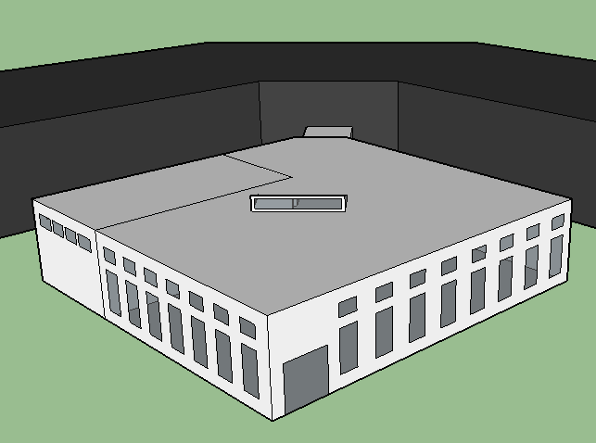 | Problem:  The cafeteria receives too much daylight in some areas making spaces uncomfortable during occupied hours. The client would like to investigate adding shading to improve the daylight levels.
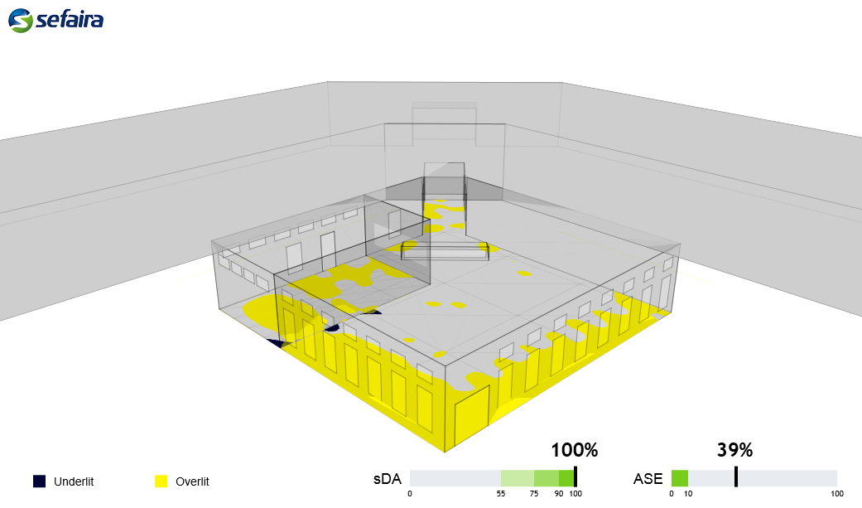

Cafeteria retrofit daylighting study

SHADING OPTION 1
115 E 23rd St, 11th Floor, New York, NY 10010
646-519-3254 | info@sefaira.com | sefaira.com

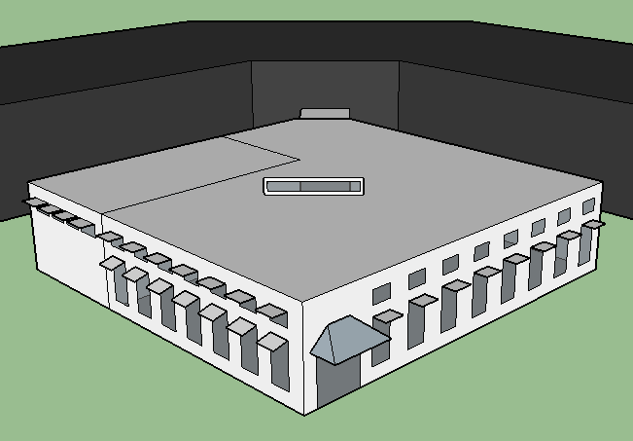 | - 2.2’ shades over south facing windows  - Shades over lower south facing windows are angled at 15°  - 2.2’ shades over east facing lower windows
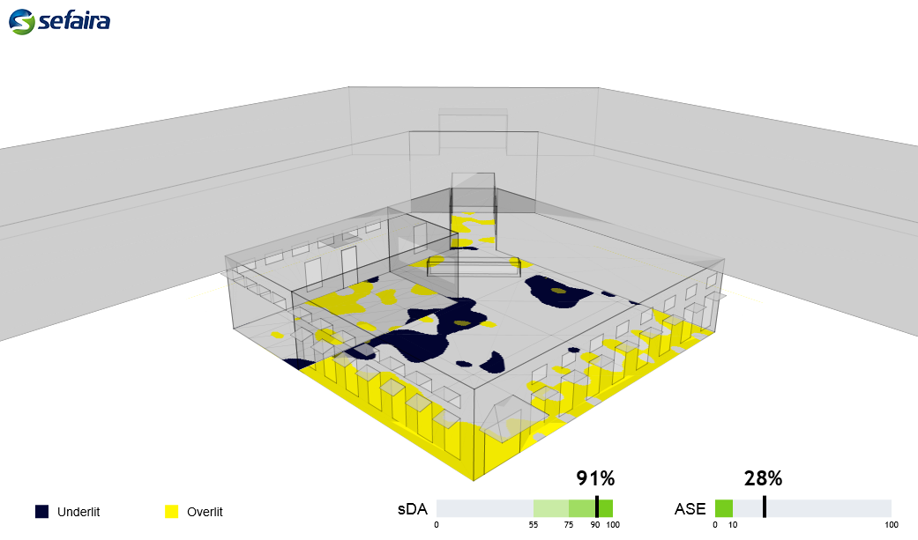

Cafeteria retrofit daylighting study

SHADING OPTION 2
115 E 23rd St, 11th Floor, New York, NY 10010
646-519-3254 | info@sefaira.com | sefaira.com

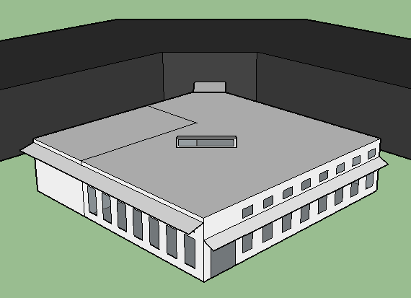 | - 4’ shade over south facing windows located 1’ from roof height angled at 15°  - 3’ shade over lower east facing windows are angled at 25°

